 | Stay on top of your health! | (Insert  Logo)
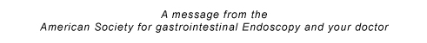
----------------------------------------------------------------------------------------------

From: _______________________________________

To: _________________________________________

I would like to share the results of your patient’s recent colonoscopy.

Patient Name: _______________________________

Date of Colonoscopy: ________________________

- Exam results:

Normal – No polyps

Polyps removed:
(number of polyps removed)

- Type of polyps removed:

Adenomatous -- a benign, precancerous growth.

Hyperplastic -- a benign growth with no potential to develop into cancer.

Other -- _________________________

- Follow-up exam:

I recommend a follow-up colonoscopy for this patient in years
from the exam date ____. (date of colonoscopy)

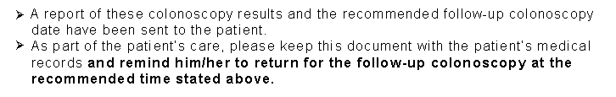
-more-

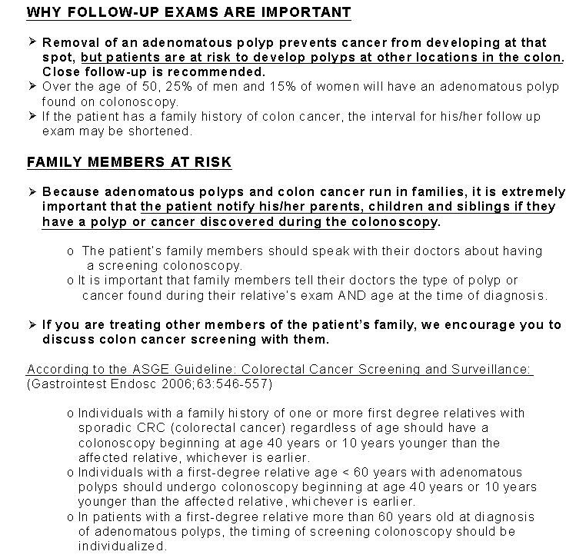
Notes:__________________________________________________________________

__________________________________________________________________
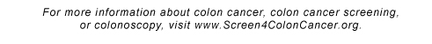
Endoscopist’s Contact Information:

Name: ___________________________________

Address: _________________________________

Phone: __________________________________

