 | Stay on top of your health! | (Insert  Logo)
----------------------------------------------------------------------------------------------

We would like to share the results of your recent colonoscopy.

- Exam results:

Normal – No polyps

Polyps removed: _________________
(number of polyps removed)

- Type of polyp(s) removed:

Adenomatous -- a benign, precancerous growth.

Hyperplastic -- a benign growth with no potential to develop into cancer.

Other -- ___________________

- Follow-up exam

Your doctor recommends a follow-up colonoscopy in years
from your recent exam date .
(date of colonoscopy)

- A report of your colonoscopy results and the recommended follow-up colonoscopy date will also be sent to your referring physician:

_______________________________
(name of referring physician)

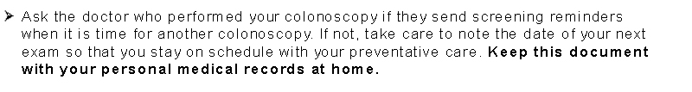
-more-
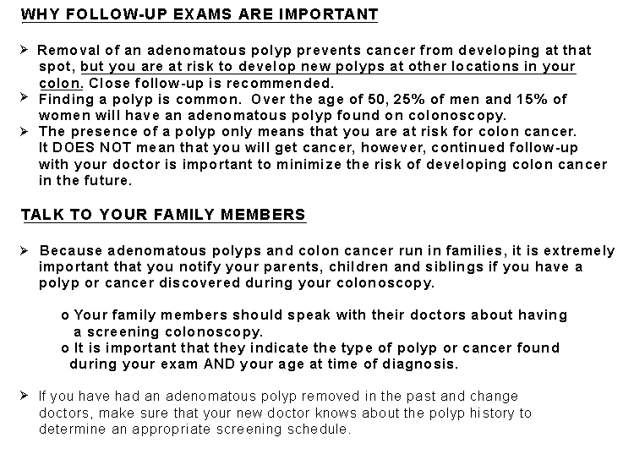
Notes from doctor’s visit or phone call:

__________________________________________________________________

__________________________________________________________________
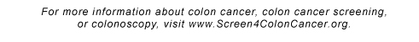
www.Screen4ColonCancer.org
Doctor’s Contact Information:

Name: _______________________

Address: ______________________

Phone: _______________________

